
Mulungushi University
School of Engineering and Technology
Computer Science Department Systems Modeling & Design
(ICT381)
Major Assignment

Week One Deliverables: Requirements Gathering and Analysis
Group 16 – Hostel Maintenance Request System

GROUP MEMBERS
STUDENT NAMES: STUDENT NUMBER:
KOMPELI SIBESO 202308158
IMANGA SONGISO 202303981
ADRIAN NGULUBE 202306966
SIABONGA PHIRI 202302370
PILIRA BANDA 202301821
BLESSINGS NKHATA 202201327
ENELESS MWANZA 202306493
ISREAL BOPILI 202302240
SANDRA KATEMBULA 202305832
SHAMMAH MUSUKWA 202305900

Vision Summary
The Hostel Maintenance Request System is a mobile application designed to streamline the process of reporting and resolving maintenance issues within student residences. The current system, often reliant on paper forms, phone calls, or front-desk visits, is inefficient, leading to delayed repairs, poor communication, and student frustration.
This system will provide a centralized digital platform for students to log maintenance requests (e.g., plumbing, electrical, furniture) with ease, attaching photos for clarity. It will allow them to track the real-time status of their requests from "Open" to "In Progress" to "Resolved." Caretakers and technicians will have a dedicated view to manage assigned tasks, update progress, and communicate resolutions.
The primary goals are to increase operational efficiency for the maintenance staff, improve transparency and communication for students, and reduce the overall resolution time for hostel maintenance issues, thereby enhancing the student living experience.

Project Goals

1. Faster Reporting and problem fixing. This provides a direct, digital channel for students to log issues instantly from their devices, eliminating paper forms or in-person visits.
2. Tackle occurring problems in real time, this leads to faster response time and avoids accumulation of unresolved issues
3 Enhanced communications between students and staff, which reduces response time.

ADVANTAGES OF THE SYSTEM
FOR STUDENTS
1. Creates new request for students to submitting a mandatory title. This assigns a difficult level to the request, providing accurate data on the priority of work.
2. Improved Tracking and Accountability. All requests are centrally logged and stored in a database, creating a permanent record. This allows staff to monitor performance and identify recurring issues.

FOR TECHNICIANS/ STUFF
1. Manage Workload. Technicians can view all requests and filter them by status, category, or priority. They can also search for requests using keywords. Identify overdue requests that need immediate attention.
2. Update Request Status: Technicians can change the status of a request (e.g., from OPEN to IN_PROGRESS). This always other technicians to understand what has been solved and what has not.

3. Communicate Progress Technicians must add. Progress Notes to a request to document their work. A request can only be marked as RESOLVED if at least one progress note exists, ensuring a record of the action taken.

4. Attach Evidence: Technicians can also attach photos, for example, to show a completed repair.
Stakeholder Identification
STAKEHOLDER | ROLE/INTEREST | DESCRIPTION OF INVOLVEMENT
Student | End user | Submits maintenance request
Technician | End user | Attends to maintenance requests
Administrator | System manager | Manages the system and views system reports

Functional Requirements
System shall allow lecturers to mark attendance for each class.
System shall generate attendance reports per course.

Non-Functional Requirements
System should respond within 3 seconds of user action.
System must ensure data security via role-based access.

Requirements, User Stories and priorities

ID | Requirements Description | Priority | User Story | Acceptance Criteria
FR-1 | Submit a new maintenance request | Must | As a student, I want to submit a new maintenance request with title, category, location, and description, so that the maintenance team is aware of the issue. | - Form has required fields (Title, Category). - Location auto-populates or includes Block/Room. - Submission creates a new request with "OPEN" status.
FR-2 | Attach photos to a request | Should | As a student, I want to attach photos to my request so that I can provide visual evidence of the problem for clarity. | - An "Add Photo" button launches the device's gallery/camera. - A maximum of N photos can be attached. - Thumbnails are shown in the form.
FR-3 | View a list of my requests | Must | As a student, I want to see a list of all my submitted maintenance requests so that I can track their status at a glance. | List is displayed in a RecyclerView. - Each list item shows title, date, category, and a status chip (OPEN/IN_PROGRESS/RESOLVED). - List can be sorted/filtered
FR-4 | View detailed request information | Must | As a student, I want to tap on a request from the list to see its full details so that I can read the description, see attached photos, and view any progress notes. | - Details screen shows all submitted data.  - Displays progress notes and technician assignment info.  - An edit button is visible only if status is "OPEN" and no technician is assigned.
FR-5 | Edit or cancel my own requests | Could | As a student, I want to edit or cancel my request so that I can correct mistakes or withdraw the request if I fixed it myself. | - Edit option is only available if request status is "OPEN" and no technician is assigned.  - Changes are saved and reflected in the list/details view.
FR-6 | Filter and search requests | Should | As a student, I want to filter my request list by status, category, or priority and search by keyword so that I can quickly find specific requests. | - A filter icon opens a bottom sheet with filter/sort options.  - The RecyclerView updates dynamically based on selected filters.  - Search bar filters list items by keywords in the title/description.
FR-7 | Update request status (Technician) | Must | As a technician, I want to update the status of assigned requests and add progress notes so that students are informed about the progress of their repair. | - Technician view shows requests assigned to them.  - Status can be changed from "OPEN" to "IN_PROGRESS" to "RESOLVED".  - A progress note is required before marking a request as "RESOLVED".
NFR-1 | Usability | Should | The app should be intuitive with large tap targets and clear hints for required fields. | - Buttons and status chips are easy to tap.  - Form validation provides clear error messages.
NFR-2 | Offline | Could | The app should gracefully handle loss of network connection. | - An offline banner is displayed when no internet is detected.  - Data is cached locally and synced when connection is restored.
NFR-3 | Performance | Must | The app should load requests and images smoothly without significant lag. | - The RecyclerView scrolls smoothly.  - Images are optimized for quick loading.

Assumptions, Constraints, and Risks
Assumptions:
- Students and technicians have access to an Android smartphone.
- Users (students and technicians) have valid login credentials provided by the hostel administration.
- The system will be used within a single hostel complex.
Constraints:
- The initial version (MVP) will be developed only for Android.
- Students can only edit their requests if the status is "OPEN" and no technician has been assigned.
- A request can only be marked "RESOLVED" if at least one progress note has been added.
Risks:
- Risk: Technicians may not update request status promptly, reducing system effectiveness.
  - Mitigation: Incorporate notifications and administrative oversight.
- Risk: Photo uploads may consume significant data and storage.
  - Mitigation: Implement image compression and a limit (N) on the number of photos per request.
- Risk: Feature creep could delay the initial launch.
  - Mitigation: Strictly adhere to the prioritized backlog.

Initial Domain Glossary
- Request/Issue: A reported maintenance problem submitted by a student.
- Student: The resident who submits a maintenance request.
- Technician/Caretaker: The staff member assigned to resolve a maintenance request.
- Status: The current state of a request. Values: OPEN, IN_PROGRESS, RESOLVED.
- Priority: The urgency level of a request. Values: LOW, NORMAL, HIGH. Default is NORMAL.
- Category: The classification of the issue. E.g., PLUMBING, ELECTRICAL, FURNITURE.
- Progress Note: An update or comment added by a technician describing the work done on a request.
- Backlog: The list of all requirements and features planned for the application.

Context Diagram
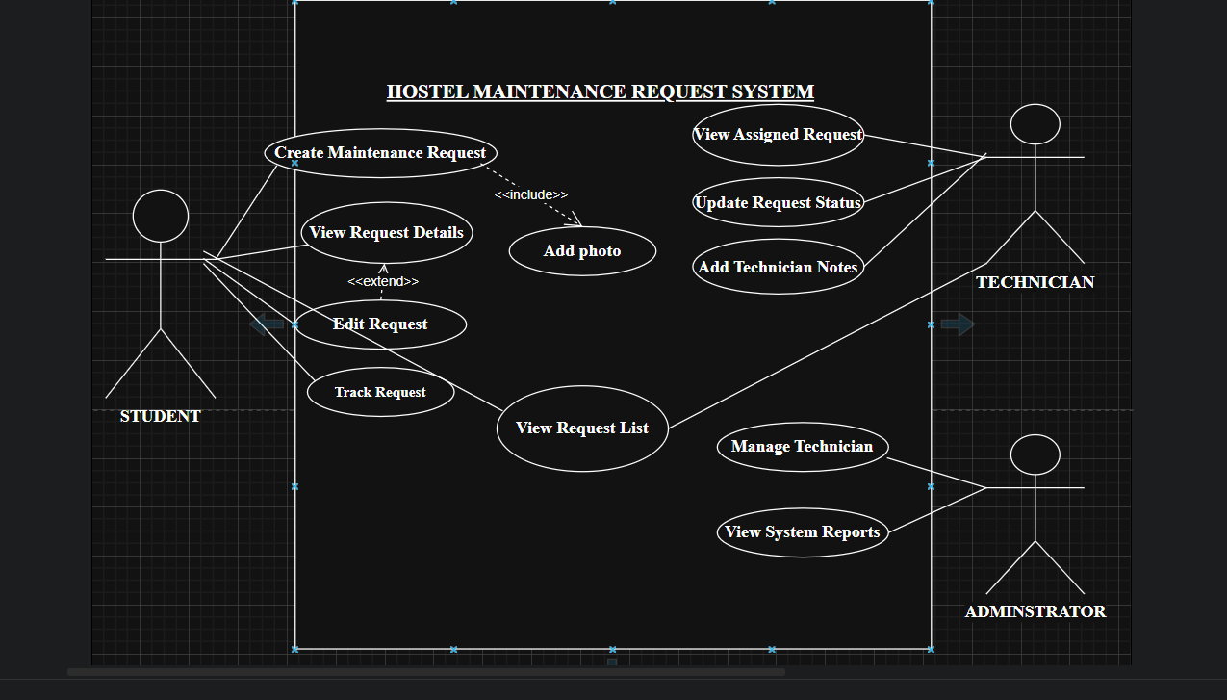

Drafted backlog for week two
Description | Planned Output
Record attendance | Use Case and Sequence Diagram
Generate reports | Use Case and Sequence Diagram
Manage user accounts | Use Case

Conclusion
The Week 1 exercise for the Hostel Maintenance Request System successfully defined the system’s graphical user interface and user interactions. The designed screens and navigation flow clearly outline how students, technicians, and administrators will engage with the system to report, track, and resolve maintenance issues.
The proposed interface prioritizes usability, accessibility, and clarity, ensuring a seamless experience for all users. This initial design establishes a solid foundation for the next phase of development, where the focus will shift to defining system logic through use cases, controllers, and sequence diagrams in Week 2.

